**HOPE JUNIOR SCHOOL.**

**END OF TERM 3 EXAMINATION -2024**

**ENGLISH.**

**TOP CLASS**

Name: _______________________________________

Class: ________________________________________

1. **Change capital to small letters**

BOOK ______________

BASKET ______________

STOOL ______________

FLOWER ______________

UMBRELLA ______________

TREE ______________

1. **Fill in the missing letters**

|  |  |  |  |  |  |  |  |  |
| --- | --- | --- | --- | --- | --- | --- | --- | --- |
| a |  | c |  | e |  | g |  | i |
|  | k |  | m |  | o |  | q |  |
| s | t |  | v |  | x |  | z |

1. **Complete the sentences**

It is a ______________

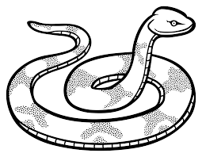

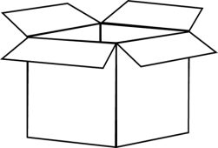This is a ___________

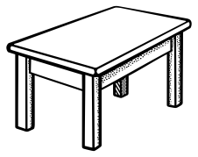I can see a_________

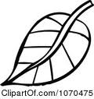That is a _____________

Here is an_____________

It is a ______________

1. **Name things used to clean our environment.**

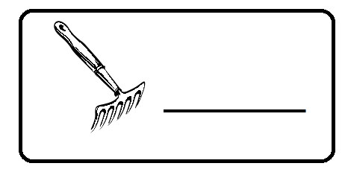 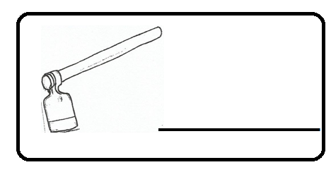

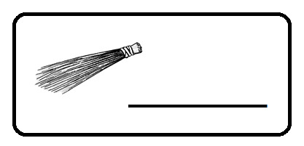 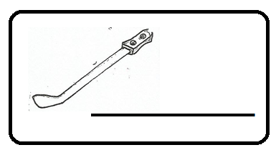

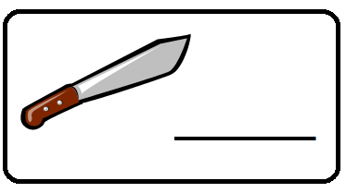

1. **Write the correct prepositions**

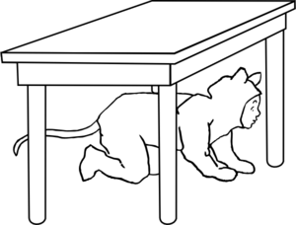The cat is ___________the table.

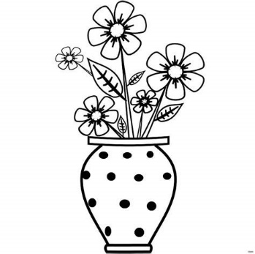The flower is __________the pot.

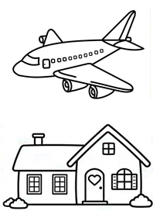The aeroplane is flying _________the house.

The water is ________the glass.

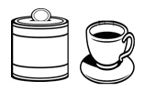The tin is __________a cup.

1. **Read and colour.**

It is a yellow moon.

That is a green leaf. 

It is a blue cup. 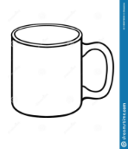

This is a black box. 

Here is a red apple. 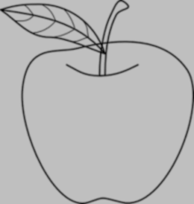

1. **Read and draw**

A cat and a rat.

A man and a fan.

A mat and a bag.

A bed and a hen.